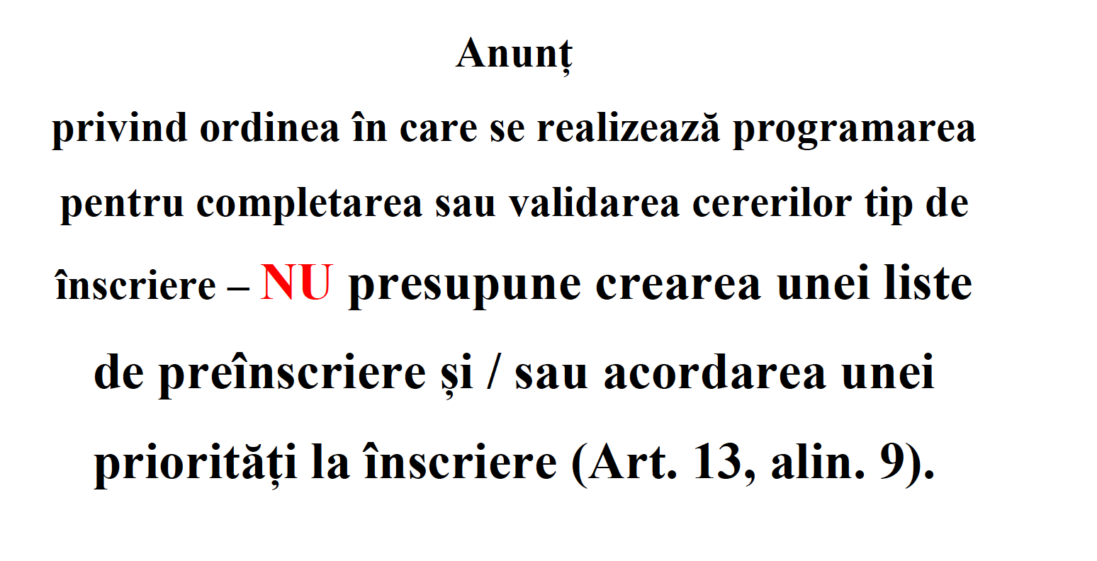

DIRECTOR,

AURELIA BERBEC